Экологический проект по английскому языку для 8-11 классов
Цели проекта:
-Развивать экологическое сознание и экологическую культуру детей.
-Активизировать познавательную деятельность, создать условия,
побуждающие детей с вниманием и заботой относится к природе;
-Познакомить учащихся с факторами загрязнения окружающей среды;
-Содействие формированию высоконравственных качеств любви ко всему живому;
-Углубить и систематизировать знания об экологических факторах
среды и их содействие на организмы;
-Сформировать чувство ответственности у каждого за судьбу России и планеты Земля в целом;
Задачи:
-Учить детей быть ответственными за свои поступки.
-Формировать культуру поведения в природе.
-Обогащать представления об окружающем мире.
-Развивать творческое воображение, познавательные возможности детей.
-Воспитывать бережное отношение к окружающей среде, необходимо
рационально относиться к компонентам неживой природы.
-прививать любовь к природе, желание о ней заботиться, заботиться о своём здоровье.

Оборудование:
-компьютер,
-проектор,
-презентация к занятию,
-плакат на природоохранную тему, выполненный учащимися.

Look Outside, see the trees
Watch the flowers in the breeze
Things won't be like this in a year or two
If polluting is all we do
Seize the night , Seize the day
Things won't always be .......
(By Josie Graveling)

It's a beautiful summer morning. Through the open window we heard
singing of birds ,meowing of cats and we feel smelling of flowers from the garden. The air is clean and clear. The crystal-clear drops of rain
patter on the on the window. It's easy to breathe in these moments ...
How do you like this situation?
There are only asphalt roads in your gardens and there are no flowers no grass there is only poison dust where some mutants are. In the air these is very strong sickly smell.The sun's disk in non-natural red and little clouds are colour of mould. It is clear that nobody wants to open their windows to breath fresh air in the early morning.
We feel terror-stricken frow that destroying the environment webring nearer the apocalypse with our actions. Our wonderful planet Earth needs protection! No wonder the Tuscan Federation was been declared 2013 as the Year of Environment.
Let’s imagine what will be with all humans in the near future. Children will not ask to go for a walk because it’s bad to breathe polluted air. They will never see any animals or birds; they will not be able to lie on the grass and to climb trees. It will be only emptiness and darkness everywhere. No sun in the sky! It will be such depression so we’ll want to howl with inconsolable grief.
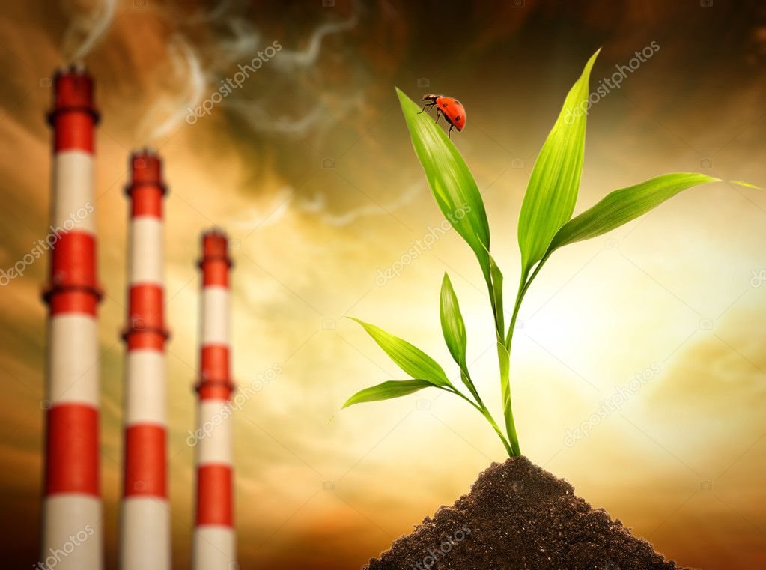
Our progeny will admire nature in the movies and on the Internet asking the same questions: “ What’s happened? Who is to be fault? “ And suddenly it will dawn upon all of us with a terrible discovery : we, people ,have destroyed out environment to such a condition. Flowers and preserves have disappeared from the Earth , fresh water almost has left our planet and serious shortages of oxygen have begun. The sun has stopped shining and every living thing is slowly dying… Is it really people deliberately move to their death?
But environmental disasters took place one after another in the history of mankind. You do not have to go far. Ukrainian city of Chernobyl was exposed to radiation disaster in 1986. As a result , everything was killed around the city ; the radiation was spreading to neighboring countries – Russia , Poland and Belarus.
Until now, people prohibited to live in Chernobyl region. And here is another example . I the Japanese city of Fukushima there was another radiation accident in 2011 much worse than in Chernobyl. The earthquake was happened to spring a leakage of radiation in strength of seventy-two thousand times greater than the nuclear bomb was exploded over Hiroshima . Consequences of such accidents are massive disease of human cancer and high mortality.
We finally have to realize that it is impossible to cut off the branch on which we are sitting . A man imagines himself the master of nature. In this age of up-to-date technologies we have imperceptibly become the barbarians from civilized, competing with each other in the mining of natural recourses , building of nuclear power stations . And yet, you need to carefully use the natural resources of the earth , not destroy the ozone layer of the atmosphere to appreciate the beauty of our world .
How great it is to re-read the works of Russian writers and poets about nature. For example , “Pantry Sun “ by M.M. Prishvin , “ Lesnaya Gazeta” by V.V. Bianchi , stories by K.G. Paustovskii, poems by S.K. Esenin and N. Rubtstcov. In these works the authors tell us about the seasons , show the beauty of nature , and take our notice to the lives of animals and birds and that people are a part of nature too. It is known that the emptiness is not in nature . Is it the same for our surrounding ? If the environment becomes unsuitable for humans the life will disappear itself from the Earth !
So we all need to take measures to save our nature. We must spend resources reasonably , limit emissions of gas in the air , liquidate dump of refuse , save the rare species of animals , birds and fish. If we do not do this the death of our Earth is imminent. People birds and animals … we all are children of our planet. And the children must be thankful to their parents!
